A Study on the Paragenesis of Myanmar Ruby Deposits

Ayla Pamukcu
Advisor: Dr. George Harlow

Introduction
Political Restrictions
For many centuries The Mogok Region of Upper Myanmar (Burma) has produced some of the most fantastic rubies, sapphires, and spinels in the world. Unfortunately, access by foreigners to this mineralogical paradise has been limited since the 1960s, a result of political changes in Myanmar, known as Burma up to that time. In addition to limiting access, the government has also maintained limits on specimens allowed for export. For a brief period between 1999 and 2002, all access privileges for foreigners were halted entirely. Moreover, isolation of residents, including scientists, to contact with the outside world and impoverishment has extremely limited internally sponsored geological research, which combined with visitor restrictions, leaves geological knowledge of the Mogok region at a pre-1960s level. Thus, the complex geology of the Mogok region and the paragenesis of its rubies is not well understood.

Geologic Setting
The corundum and associated minerals for this study were sourced from the Mogok Metamorphic Belt (MMB) (Fig 1), which was best described by Chhibber (1934a,b). The MMB is part of the Shan Highlands and is characterized by variable-grade metamorphics (greenschist to granulate facies – Bender 1983), metamorphosed sedimentary limestone and shale, and granitic and syenitic intrusive rocks. (Bertrand and Rangin, 2003).

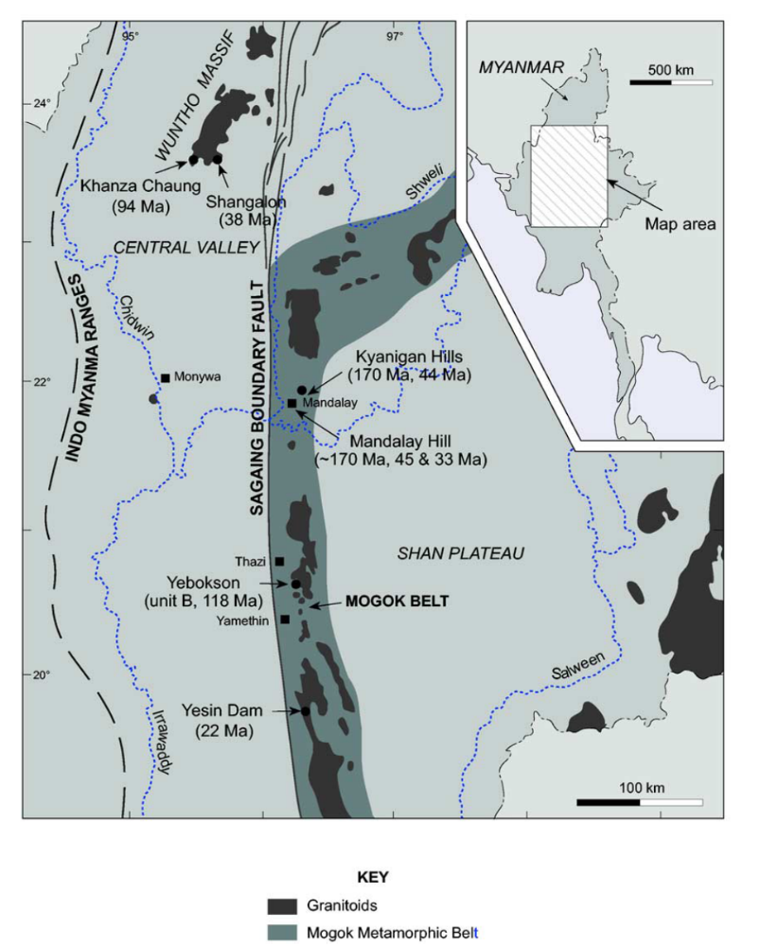

Figure 1. Map of the Mogok Metamorphic Belt (after Barley et al, 2003)

Metamorphism in the MMB is attributed to multiple tectonic and igneous events that occurred in Southeast Asia between the Mesozoic and early Cenozoic (Fig.2): (1) the collision of the Burma Plate with Asia, concordant with granitic intrusions (early Cretaceous), (2) the subduction of the Tethys III ocean, which led to further generation of igneous intrusions (mid-Cretaceous), and (3) the collision of India with Southeast Asia, well-known for the uplift of Tibet and the Himalayan orogeny, but also by subduction of continental sediments beneath Central Myanmar which led to Eocene granitic intrusions (Barley et al. 2003, Bertand and Rangin, 2003).

Figure 2. Tectonic evolution of SE Asia between Mesozoic and early Cenozoic
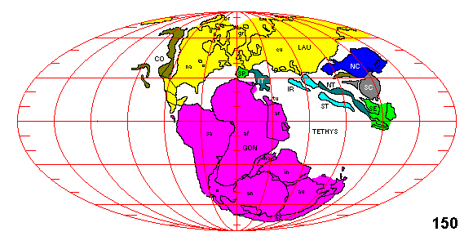

150 Ma-Burma plate collides with Asia plate

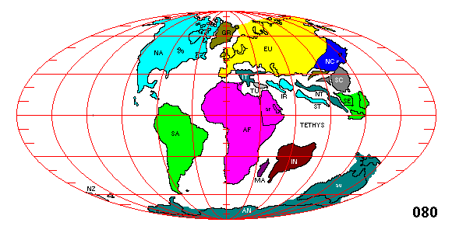

80 Ma-Tethys III ocean closes

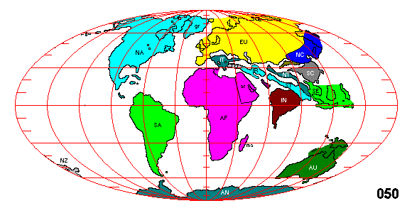

50 Ma India-India collides with SE Asia

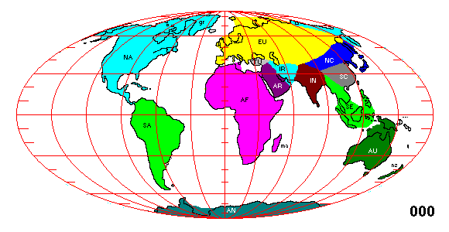

Present day

While these large regional events explain the setting and origin of the metamorphic belt, the chemical and physical processes that resulted in the genesis of the brilliant corundum crystals in the marble are still being debated. The main problem in explaining the origin of corundum lies in the fact that most metamorphic models will not transform clays in marble to corundum; rather they are to silica-rich and yield aluminosilicates. The extant hypotheses on the process of corundum formation (its paragenesis) have been discussed by various researchers (e.g., Kol’tsov et al. 2002, Garnier 2003):
(1) Desilication of silicon-aluminum sediments followed by subsequent metamorphism of limestone beds containing residual hydrous alumina minerals,

(2) Metamorphism of tropical paleosols, e.g., bauxite and white-bauxite,

(3) Conversion of spinel to corundum by carbon dioxide-rich fluids.

(4) Desilication of marble by metasomatic fluids emanating from alkaline intrusions.

Although there is considerable interest in elucidating the paragenesis of corundum in Mogok marbles, scant investigation of field relationships has been possible, and few samples have been available. Moreover, study of the minerals coexisting with corundum has been mostly neglected, for lack of samples. Microscopic examination of recently acquired samples shows that the mineral assemblages are more diverse than previously appreciated. Consequently, identification of the phases and their textural relationships with the corundum is warranted. The data garnered from such study provides a plethora of new information vital to understanding the complex history of the mineral deposits of the Mogok Region.

Materials and Methods
The 91 samples analyzed in this study reside in mineral collection of the American Museum of Natural History. Whereas 32 specimens are denoted simply as originating in Mogok, hence from potentially anywhere in the region (i.e., the map area in Fig. 3); fourteen specific mine localities are known for 59 of these samples: Dattaw, Kyauksartaung, Kyaukpyatthat, Kolan, Kadokedat, Pyaung Gaung, Oin Dan, Kyaukpoke, Baw Maw, Mong Shu, Chaung Gyi, Sagyin, Borima, Pein Pyit; and X are from other deposits: Sagyin, between Mandalay and Mogok, and Mong Shu, much farther south in the Shan state. At the present time, due to the inadequately detailed maps and poor communication with those in Myanmar, we are unable to locate some mines/collection sites on the map in Fig. 3.

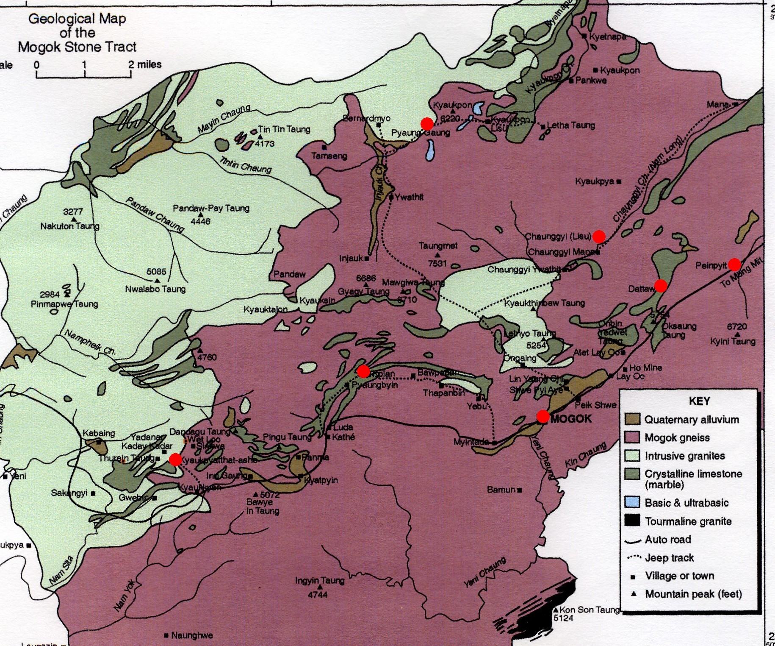
Figure 3. Geologic Map of the Mogok Stone Tract. Seven of the sample localities are highlighted: Dattaw, Pein Pyit, Kyaukpyatthat, Kolan, Chaung Gyi, Pyaung Gaung, Mogok. (after Iyer, 1938)

All samples were initially studied with a binocular microscope, and potential discrete phases were identified. Grain fragments on the order of 100 μm across were sampled for each recognized phase from a specimen. One or more of these fragments were glued to the end of a thin glass fiber attached to brass pin. This pin was placed into a sample holder, which was attached to the sample stage a RIGAKU D/MAX RAPID High Sensitivity/Resolution Curved Imaging Plate Microdiffractometer in the diffraction laboratory at the AMNH. The grains were optically centered to the instrument, and automated X-ray exposure to monochromated Cu Kα radiation with the RAPID XRD program. Samples were oscillated about a vertical axis (ω) and rotated around a ϕ-axis inclined at 45° (fixed) from ω to obtain sufficient diffractions on the cylindrical image plate which would integrate into a diffractogram with well-defined peaks. The following conditions were generally used (see also Fig. 4):
(1) Collimator: 0.8 mm
(2) Exposure time: 10 minutes
(3) X-rays:
- Tube voltage: 46 kV
- Tube current: 40 mA
(4) Omega-axis movement: -15 to 60 degrees , 1 deg/sec
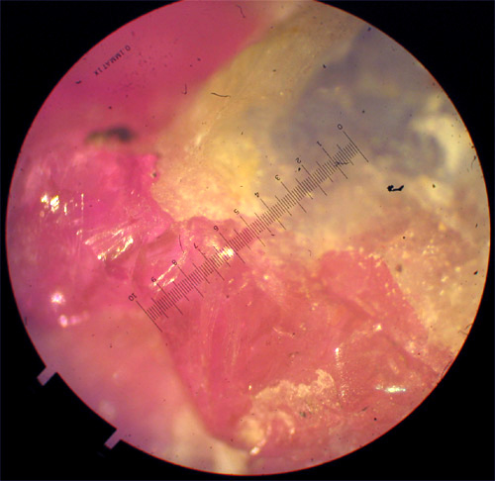
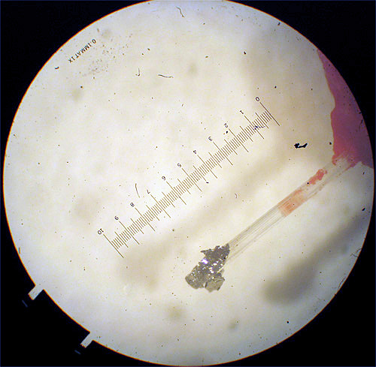
(5) Phi-axis movement: 0 to 180 degrees, 3 deg/sec
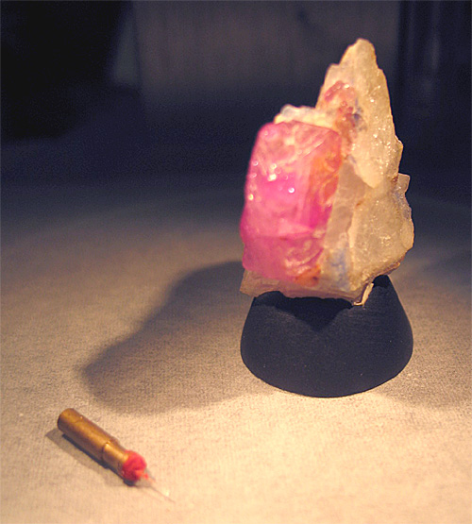

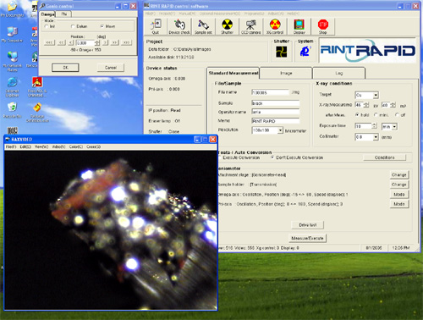
Figure 4. Sample preparation: sample to be analyzed; multiple phases visible under microscope (10x); sample attached to glass fiber (10x); sample in sample chamber; RAPID XRD program
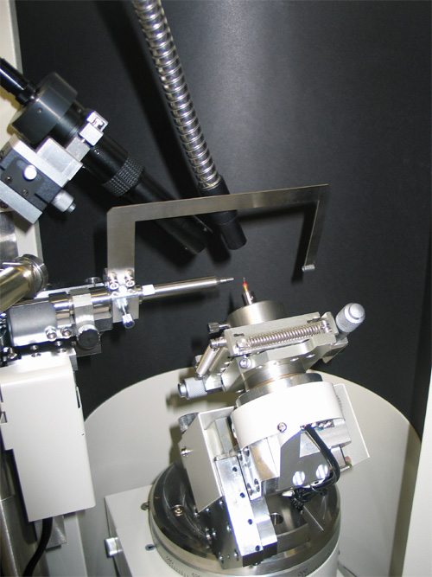
At the conclusion of X-ray exposure, the digital two-dimensional diffraction pattern from the image plate is integrated into a standard diffractogram (two-theta scattering angle versus X-ray counts) with Rigaku’s AreaMax software (fig. 5). Patterns were interpreted with Jade 7.0 (MDI) software. In this program, background and K-alpha2 peaks are stripped and peaks centers are fit and intensities integrated. A search match procedure in Jade compares the observed diffractions to the ICDD PDF-2 set of diffraction patterns or synthetic patterns available in the PDF-2 file or downloadable from the American Mineralogist Crystal Structure Database (http://rruff.geo.arizona.edu/AMS/amcsd.php) (Fig 6)
X-ray diffraction and search/match routines do not provide unique identifications among members of many mineral families. In general, there may be several close matches among, let’s say, tourmalines including Mn-elbaite, olenite, uvite, and dravite. Without independent chemical information or analyses to distinguish among these minerals, it is not really possible to assess whether the phase is the NaLi phase (elbaite), the NaAl phase (olenite) or a more Ca-rich phase (uvite). Consequently, I went with the best match, and we have posited caveats which require further investigation.
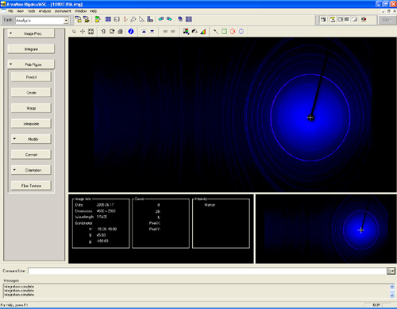
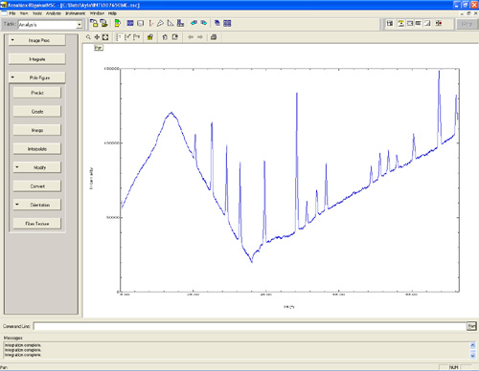
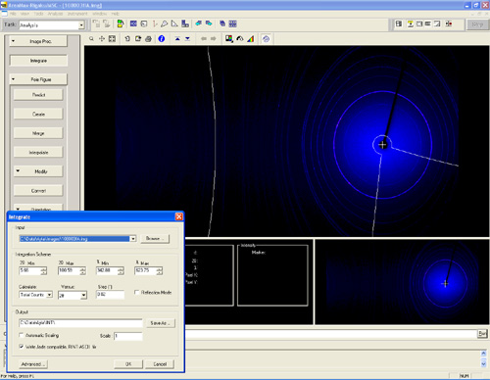
Figure 5. AreaMax integration: (upper): digital powder diffraction pattern; integration of diffraction pattern; (lower) graph result of integration

Figure 6. Analysis of integrated pattern with Jade 7

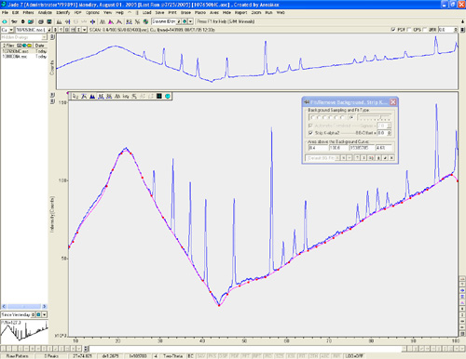

a. stripping of background and K-alpha2

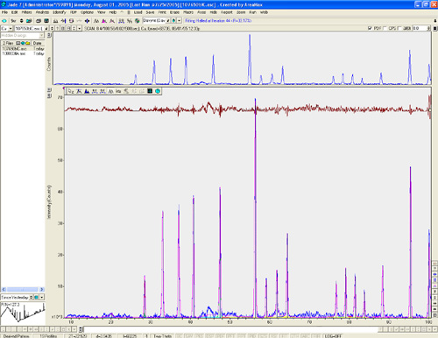

b. integrated peak profile

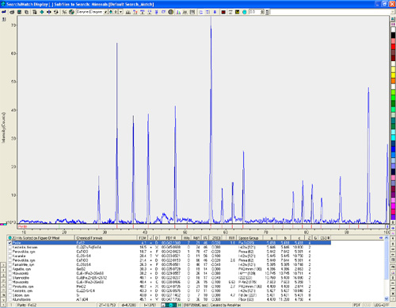

c. mineral name match

Results

In all, 52 different minerals were identified among the 91 specimens studied. To assess variations in parageneses among different mines and areas, the phase identifications were compiled into a database (spreadsheet?) based on the attributed geographic locality/source (See Appendix A). A simplified version is given in Table 1, with some of the caveats discussed above, included.

Table 1
Locality | # Samples | Minerals Present
Baw Maw | 4 | corundum (sapphire), hercynite (a spinel), microcline, phlogopite, spinel
Borima | 2 | Spinel, calcite
Choung Gyi | 4 or 9 | apatite, calcite, diopside, graphite, moonstone (alkali feldspar –Ab₉₅An₃Or₂ to Ab₆₉Or₂₈An₃), nepheline, phlogopite, scapolite (marialite/mizzonite?), spinel (hercynitic?) (secondary barite and dickite)
Dattaw | 26 | amphiboles (magnesiosadanagaite, pargasite) buergerite-foitite (-like tourmaline), calcite, cancrinite (blue and colorless varieties)-hydroxycancrinite-quadridavyne?, corundum (ruby, sapphire), diopside, fluorapatite, graphite, marialite-(mizzonite)-meionite/, muscovite, nepheline, phlogopite-annite, , pyrite, pyrrhotite, sodalite (colorless), spinel, and titanite (secondary diaspore, goethite, halloysite, montmorillonite)
Kadokedat | 7 | albite, augite, buergerite (or similar tourmaline), calcite, corundum (ruby & sapphire), graphite, pyrrhotite, rutile, spinel, titanite (secondary goethite)
Kolan | 1 | Calcite, corundum (ruby), graphite, muscovite (fuchsite), pyrrhotite, scapolite(?)
Kyaukpoke | 2 | calcite, corundum (ruby), pyrite, sanidine (secondary halloysite)  spinel, clinohumite(?), calcite
Kyauksartaung | 1 | calcite, corundum (ruby), muscovite, sanidine, srilankaite
Kyauk-Pyat-That | 1 | corundum (ruby), (secondary gibbsite)
 | 5
Mogok | 27 | albite, annite, anorthite, calcite, chukhrovite, corundum (ruby, sapphire), diopside, dolomite, enstatite, ephesite (margarite, or another mica), ferrotschermakite (or similar amphibole), fluorapatite, graphite, halloysite, herderite, labradorite, marialite, marialite (mizzonite), moonstone (alkali feldspar ), nepheline, pargasite, phlogopite, prehnite-after-labradorite?, pyrite, pyrrhotite, sanidine, scapolite, spinel, titanite, zircon, zirconolite (secondary böhmite, gibbsite, goethite)
Oin Dan | 2 | corundum (sapphire), nepheline/plagioclase altered to gibbsite, spinel
Pein Pyit | 10 | Spinel: calcite, chondrodite, clinohumite, corundum, diaspore, graphite, molybdenite, pyrite (alluvial quartz)  Moonstone (alkali feldspar – Ab₉₅An₃Or₂ to Ab₆₉Or₂₈An₃), calcite, diopside, graphite
Pyaung Gaung | 3 | calcite, diopside, graphite, pargasite, spinel  Dark moonstone (alkali-feldspar), magnetite
Sagyin | 1 | corundum (ruby), pyrite, and buergerite (or similar tourmaline)

While this record is useful for identifying patterns and making basic comparisons, it is just as important, if not more so, to consider the chemical and physical relationship of these minerals within their individual assemblages. In combining these two sources of information, it becomes apparent from this study that samples from the Dattaw locality are distinctly different from all other samples studied. First, although merely a qualitative observation, the ruby specimens from Dattaw are a shade of red-pink unlike any of the others. Second, in only these samples is a blue cancrinite phase observed and, furthermore, consistently present (often there is both a blue and colorless variety). In addition, Dattaw samples are very regularly found to have a colorless sodalite phase (a typically brilliant blue mineral; in only one instance was this colored variety seen) next to the cancrinite. It is quite surprising that we are finding both of these minerals in the same assemblage as they don’t generally form together, a strange finding made more interesting in the observation that the sodalite is colorless. These phases are nearly always directly next to corundum, frequently forming a corona around it (fig 7).

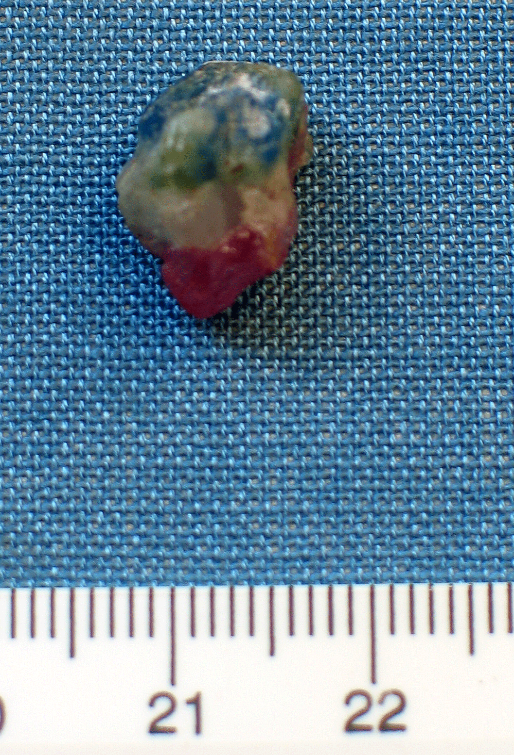
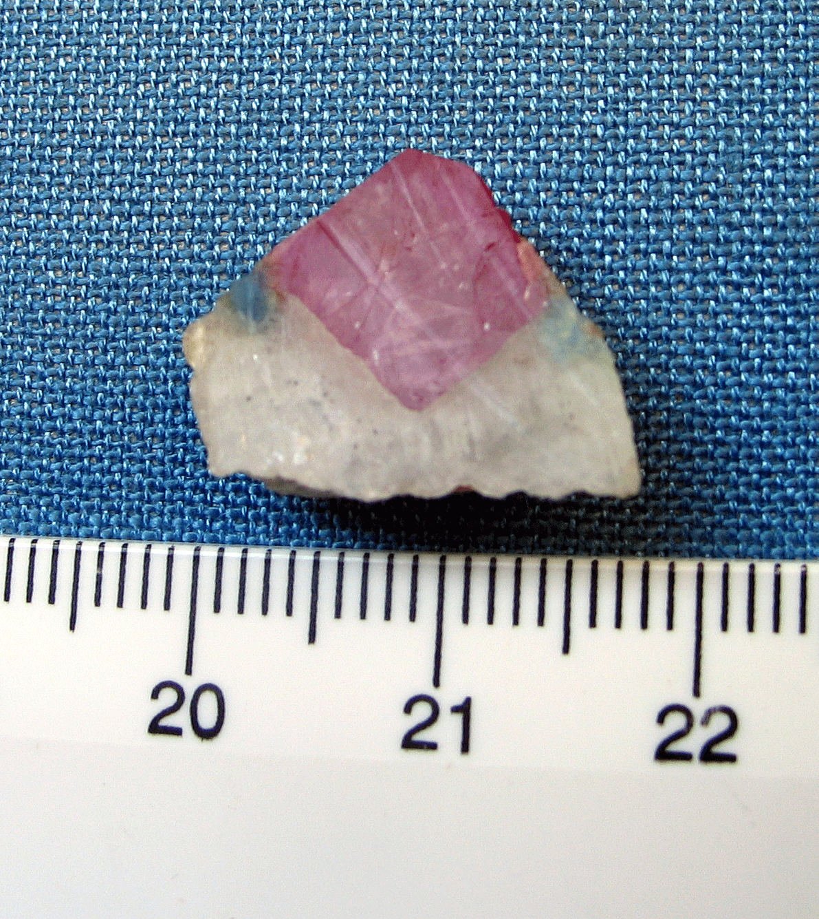
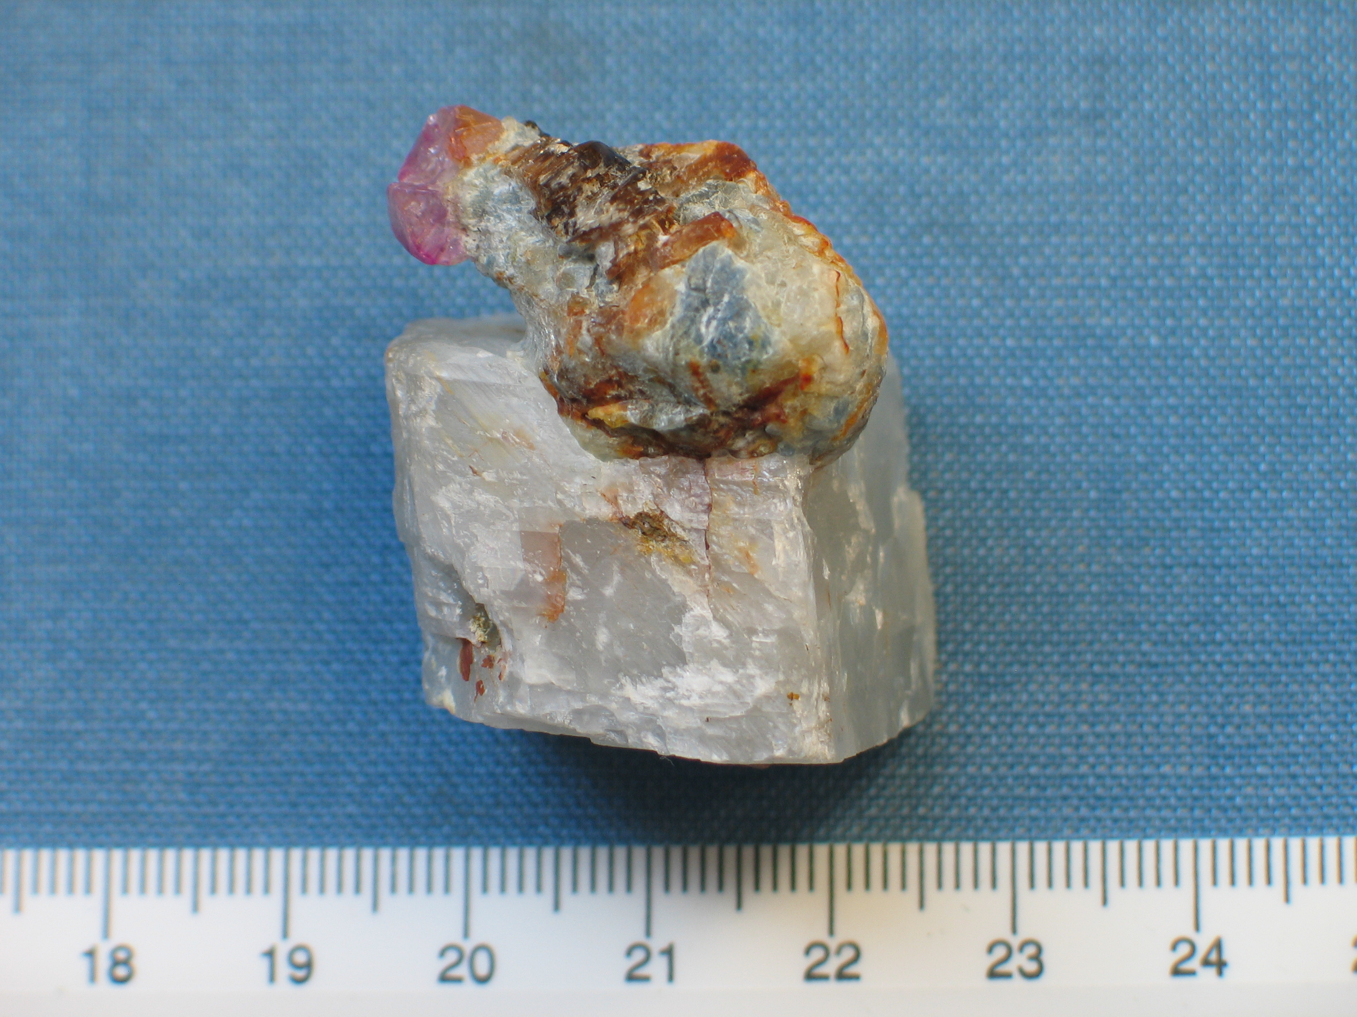
Figure 7. Contact relationship between corundum and cancrinite/sodalite phases. Note the blue cancrinite in direct contact with red corundum crystals. (Center) Cross-section of corona surrounding corundum crystal.
A third observation is that only Dattaw assemblages consistently contain a scapolite phase, typically mizzonite (a descriptive term for scapolite midway between marialite–Na₄Al₃Si₉O₂₄Cl [= NaCl + 3Ab] and meionite Ca₄Al₆Si₆O₂₄CO₃ [=CaCO₃ + 3An]). This array of minerals holds a number of elements not found in other mineral assemblages: fluorine, chlorine, sodium, boron, and sulfate. The presence of such volatile-rich minerals, and their contact relationships with other minerals, allows for a number of preliminary conclusions to be made. These conclusions will be discussed in the following section.
Another intriguing mineral assemblage is green tourmaline, potentially buergerite + corundum in marble, which was observed in samples from Kadokedat and Sagyin and now, Wet Loo. Here we see boron without the signature Cl- or F-bearing minerals such as scapolite, sodalite, or possibly davyne and the humites.
Other important assemblages to think about in light of Dat Taw and granitic rocks vs. marbles:
- Moonstone-diopside-marble (± scapolite, etc.) : Choung Gyi, Pyaung Gaung, Pein Pyit (?)
- Corundum-sanidine-marble: BawMaw(?), Kyaukpoke, Kyauk-sar-taung

A host of other odd minerals, such as chukhrovite (previously only found in Kazakhstan) and srilankaite, were also identified in this study, but they are neither abundant nor found with enough consistency to employ them in making significant conclusions concerning the environment of genesis.
Certain mineral assemblages appear to characterize certain localities, so there is the hint of a possibility in sorting out some samples dumped into the Mogok attribution, for lack of a more accurate locality, as well as possible mis-assignments – CAN YOU MAKE SOME SUGGESTIONS???

Conclusions
This study was but a mineralogical overview of the assemblages related to corundum and spinel from the Mogok Stone Tract, but the observations of Dattaw permit making a few preliminary conclusions about the geologic history of this area.
First, the presence of volatile-rich minerals (cancrinite, sodalite, scapolite, tourmaline), which are not being found in specimens from other localities, indicates that the geology of Dattaw was influenced by metasomatism of a skarn-like nature; an interaction between evolved granitic compositions (probably towards complex pegmatites and marble. Granitic and syenitic intrusives are documented throughout the region (Chhibber 1934b, Iyer 1953, Barley et al. 2003). Fluids from these intrusions introduce volatile elements and enable reactions to alter existing minerals to grow new ones. Since these elements are not found in any of the other minerals, they must have been derived from an outside source.
Second, the physical relationship between corundum and cancrinite/sodalite, signifies the possibility of a reaction between the metasomatic fluids and the already existing minerals. As fluids come into a system, they bring new elements which may react with other minerals to crystallize these new phases, creating the corona of cancrinite and sodalite we see. Furthermore, the fact that sodalite, typically blue, is found to be colorless while cancrinite is blue indicates that, in this environment of genesis, sulfur prefers the cancrinite structure over the sodalite structure. Significantly more study will be necessary to determine how and why this occurs.

Immediate Future Study
In order gain a more definitive understanding of the paragenesis of minerals from the Mogok Stone Tract, it will be important to continue to identify assemblages from as many samples as possible, hopefully with more sufficient locality and field-relation data. In addition, it will be necessary to study the thermochemistry of these assemblages in an effort to derive an understanding of the conditions and environments in which these minerals can realistically coexist. From this we can constrain the potential events that took place, formulating a much more complete theory of this very complex geologic history.

References

Barley, M.E., Pickard, A.L., Khin Zaw, Rak, P., and Doyle, M.G. (2003) Jurassic to Miocene magmatism and metamorphism in the Mogok metamorphic belt and the India-Eurasia collision in Myanmar. Tectonics 22(3), 10019, (4-1 – 4-11).
Bertrand, G. and Rangin, C. (2003) Tectonics of the western margin of the Shan plateau (central Myanmar): implication for the India–Indochina oblique convergence since the Oligocene. Journal of Asian Earth Sciences 21, 1139-1157.

Chhibber, H.L. (1934a) The Geology of Burma. MacMillan, London.
Chhibber, H.L. (1934b) The Mineral Resources of Burma. Macmillan, London.

Garnier, V. (2003) Les gisements de rubis associés aux marbres de l’Asie Centrale ed du Sud-est Genèse et caractérisation isotopicque (Ph.D. thesis]: Nancy, France, Institut National Polytechnique de Lorraine, 371 p.

Garnier. V., Giuliani, G., Maluski, H., Ohnenstetter, D., Trinh, P.T., Vinh, Hoàng Quang, Long, P.V., Van, T.V., and Schwartz, D. (2002) Ar-Ar ages in phlogopites from marble-hosted ruby deposits in northern Vietnam: evidence for Cenozoic ruby formation. Chemical Geology 188, 33-49.

Garnier V., Ohnenstetter, D., Giuliani, G., Blanc, P., and Schwarz, D. ( 2002) Trace-element contents and cathodoluminescence of "trapiche" rubies from Mong Hsu, Myanmar (Burma): geological significance. Mineralogy and Petrology 76 (3-4), 179-193.

Guillong, M., and Gunther, D. (2001) Quasi ‘non-destructive’ laser ablation-inductively coupled plasma-mass spectrometry finger printing of sapphires. Spectrochimica Acta Part B 56, 1219-1231.

Harlow, G.E., The Mogok Stone Tract, Myanmar: Minerals with complex paragenesis (transcript)
Harlow et al (pending) A guide to the gem and mineral deposits of Upper Burma (Myanmar)

Iyer, L.A.N. (1953) The geology and gem-stones of the Mogok Stone Tract, Burma. Memoirs of the Geological Survey of India, 82, pp. 100, 2 maps.

Kammerling, R.C., Scarratt, K., Bosshart, G., Jobbins, E.A., Kane, R.E., Gübelin, E.J., and Levinson, A.A. (1994) Myanmar and its gems–an update. Journal of Gemmology 24, 1, 3-40.

Kane, R.E., and Kammerling, R.C. (1992) Status of ruby and sapphire mining in the Mogok Stone Tract. Gems & Gemology, 28, 152-174.

Kol’tsov, A.B., Dufour, M.S., and Zolotarev, A.A. (2002) Genetic conditions and a model of origin of corundum-bearing metasomatic rocks in marbles. Geochemistry International 40, S113-S124.

Mitchell, A.H.G. (1981) Phanerozoic plate boundaries in mainland SE Asia, the Himalayas and Tibet. Journal of the Geological Society, London 138, 109-122.

Mitchell, A.H.G. (1992) Late Permian-Mesozoic events and the Mergui Group nappe in Myanmar and Thailand. Journal of Southeast Asian Earth Sciences 7, 165-178.

Mitchell, A.H.G. (1993) Cretaceous–Cenozoic tectonic events in the western Myanmar (Burma)–Assam region. Journal of the Geological Society of London 150, 1089-1102.

Pêcher, A., Giuliani, G., Garnier, V., Maluski, H., Kausar, A.B., Malik, R.H., and Muntaz, H.R. (2002) Geology, geochemistry and Ar-Ar geochronology of the Nangimali ruby deposit, Nanga Parbat Himalaya (Azad Kashmir, Pakistan). Journal of Asian Earth 21, 265-282.

