SWRS News

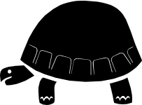

Southwestern Research Station
American Museum of Natural History
Portal, Arizona 85632

Number 18 Year 2003 Events

Parting Words

from Wade C. Sherbrooke, Director Emeritus

My first visit to SWRS was on November 23, 1963, as a new graduate student in an ecology class from the University of Arizona. Later, beginning in 1976 I camped below Portal while working on my dissertation, and finally moved to the Station on May 23, 1985, as assistant director to become director upon the retirement of Vincent D. Roth in March of 1986. Now, after more than 18 years, I look at leaving SWRS, with a new director, Dr. Dawn Wilson, having arrived in August 2003. I choose to look back first to remember and thank the people who have so enriched my experiences at SWRS, a place that is a continual Mecca for scientists and naturalists who feel some need to be closer to the natural world.
Of course, there would be no SWRS without the vision and formative energy of Dr. Mont A. Cazier and his wife Carolyn Cazier, and the support of David Rockefeller. Beetles have a permanent place in the history of SWRS, which began in 1955. My years of overseeing operations at this remote location and integrating them with the home-base American Museum of Natural History in New York City have been facilitated by my immediate supervisors Dr. Jerome G. Rozen, Jr., the late Dr. Thomas D. Nicholson, Dr. William P. Moynihan, and Dr. Michael J. Novacek. Many Museum staff members have assisted me in countless ways over the years — people in almost every department of the Museum.
But the SWRS staff members that have been with me over the years are the ones that have been closest to making sure that visitors to the Station have had wonderful experiences. In the office I have had the support of assistant directors, secretary/bookkeepers, and seasonal office assistants, and on the grounds and in the buildings the continuous efforts at repairs and upgrading of a number of maintenance men. In the dining room, cooks and seasonal cooks ordered, prepared, and served three-meals-a-day, season after season. The names and faces of these people are imbedded in my memories and in those of you who recall your personal experiences at SWRS. I am fully aware that all employees have given a great deal to SWRS. SWRS gives a lot and asks a lot of all of us, and I am thankful for the continuous efforts of the staff over the years I have been director.
The Station’s other staff consists of the volunteers who come every year to assist operations, and to become involved with field research with our scientists. Without them the Station would be hard-pressed to keep operations moving smoothly. They come for a lifetime experience, are in Cave Creek Canyon for a fraction of a year, and move on, often molded by their experiences at SWRS, to lives played out around the world. Many former volunteers enter careers in the biological sciences, some return to SWRS; all are seeds spread from the experience. How many? Since I have been at SWRS, 1985-2004, there have been 567 volunteers. As I look at the many changes over the years, of course I think of our five National Science Foundation grants and their resulting buildings, but I look at the results of volunteer projects too. I cannot conceive of having managed the Station all these years without them. They bring intensity, joy, questions, growth spurts, sharing, culture, romance, and fun.
Researchers are the engine of the Station. Their collaborations with the Station result in new knowledge and understanding,, their own career development, and the growth of those around them whom they influence. Frequently they are the intellectual gurus of the Station, and serve as inspiration for all. Many spend significant parts of their careers at SWRS, resulting in M.S. or Ph.D. degrees, or academic advancements at institutions where they teach. They bring much to SWRS and we all gain much by our associations with them. The same is true of the numerous classes of students and their instructors and conferences that visit the Station each season.
The non-scientist guests who visit the Station as naturalists bring another dimension to the interactions of human spirits and the natural world at SWRS. Often this is very personal, and sometimes shared – the joy of seeing a formerly unknown species in nature. They too enrich the Station, as do the full-time residents of the area on the eastern slopes of the Chiricahua Mountains that extend out on bajadas across the San Simon Valley. For 18 years I have been part of this community too, and have benefited from relationships ranging from Portal Rescue/Fire, Portal Post Office, Myrtle Kraft Library, Apache School, United States Forest Service, ranch owners, and more. What a community of people I have had as good neighbors. The string of memories seems unique to Portal and surrounds — 4th of July parades, gold mine coalition, bills in Congress, thick-billed parrots, Sew-What sales, etc.
Here in Cave Creek Canyon, many mornings when I arise before the sun captures the sky and turns it blue I gaze up into eternity. This too is part of living at the Station. Visitors to the Chiricahua Mountains are enchanted by the intimacy with the natural world. My family and I have been able to experience this intimacy as a way of life. Sky and Reed have thus far known no other world as home.
So as Emily and I prepare to depart we revel in the richness of all the years we have been so fortunate to have shared our lives with the people of the Station, the animals of the Canyon, the plants of the slopes, the rocks of the mountain, the rains of the sky — and the history and destiny and of an institution whose role in society has been to enhance and nurture our appreciation of the natural world that surrounds us.

1

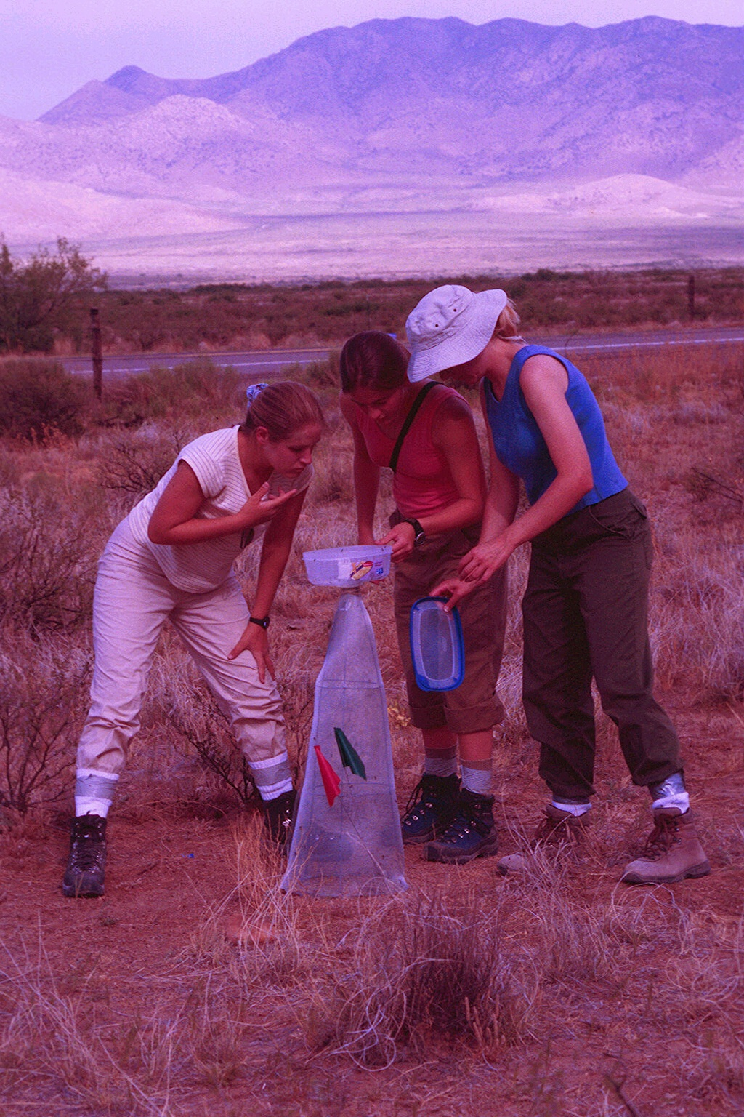

Hello
From Dawn S. Wilson, Director

I came to the Southwestern Research Station from the Biology Department at California State University, Chico. I had been an assistant professor there for four years. I taught several biology courses along with my speciality, Herpetology. I also supervised six graduate students conducting research projects ranging from temperature dependent sex determination in desert tortoises to habitat use in western pond turtles. Many of my colleagues at Chico State thought I was insane for leaving such a wonderful job in academia to move to a research station in what they thought of as the “wilderness”. My husband and I, however, felt that we were remarkably fortunate to be able to manage a research station in such a spectacular area of the country.
I arrived at the SWRS in late morning of 1 August 2003 a bit apprehensive about my new position as Director. The station had been run successfully for the past 18 years by the previous Director, Wade Sherbrooke. By the end of my first day, I came to the realization that I had some pretty big shoes to fill, and that I had better watch where I put my feet! By nightfall of my first day, three rattlesnakes were captured in the middle of the station grounds. Now, being a herpetologists, I am rather excited to see such a diversity of reptiles around the station, but I now always carry a flashlight when out and about at night.
I am extremely thankful that Wade agreed to overlap my first four months as Director and share with me his vast knowledge and experience of the day to day operations of a research station. On a somewhat daily basis we sit down and talk about topics ranging from keeping the tree limbs off the electric power lines to the needs of the many scientists that come through the station on a regular basis. In addition, I am grateful to Emily Sherbrooke (Assistant Director) and Diane Smith (Secretary/Bookkeeper) for teaching me all about the inner workings of the office, the volunteer program, and all the other things that keep the station running smoothly. I also thank Mike Stoehner (Chief of Maintenance) for his patience in letting me trail after him and peer over his shoulder while he keeps the station in working order.
My family will be joining me at the station January 2004. My husband, David Kuntz, will take on the position of Operations Manager. My kids, Cocoa and Otto, mostly will do what they do best: slobber, kiss, and protect David and me from creatures of the night. [Cocoa is a lab mix and Otto is a German short-hair pointer mix]. David has a graduate degree in Range Management. We both want to continue our scientific research and find that the area surrounding the SWRS has much to offer both of us in this respect.
I have been at the SWRS for a little over 2 months and am starting to feel comfortable with my new surroundings. I still have a lot to learn and hope to make my own mark here as Wade has done successfully over the past 18 years. Although Wade will be a hard act to follow and he and his family will be missed by all, I already feel a sense of acceptance from the people staying and working at the station, as well as the locals that live near the station. My apprehension is subsiding and I now recognize that I have one of the most wonderful jobs in the world and could not imagine a better place to reside, play, and work.

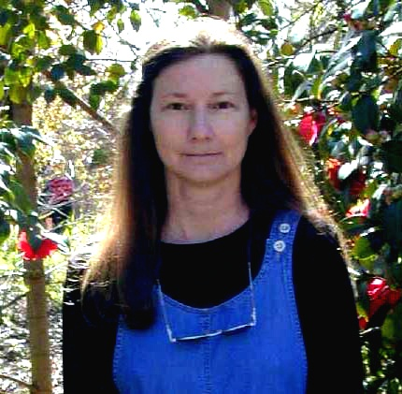

Dawn S. Wilson, Director, SWRS
David E. Kuntz, Operations Manager, SWRS


Ants and Pheromones
By Les Greenberg
University of California, Riverside

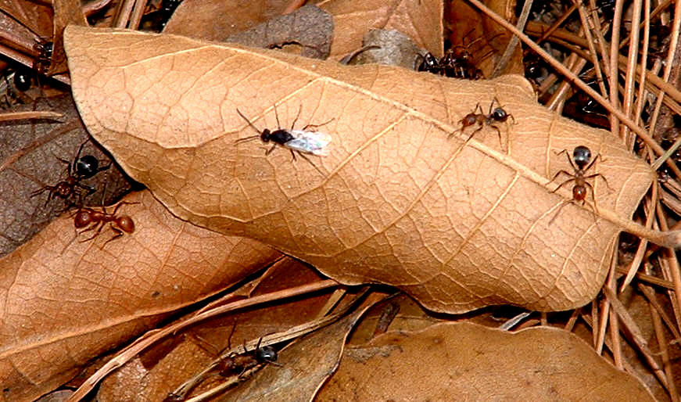

My experience with the Southwestern Research Station dates back to 1973, when I was lucky enough to be part of the first class in Animal Behavior at the Station, which was organized by Howard Topoff. That summer we observed raids by the slave-making ant, Polyergus breviceps, although most of our time was devoted to other projects.
I did not observe these ants again until 1986 when Howard invited me to join his project to assist with pheromonal trials related to slave-making behavior. I dissected out the known endocrine glands of Polyergus and tested them to see whether any of their secretions defended them against other ant species (Topoff, et al., 1988). That same summer I was observing a raiding column of ants and noticed that some of the winged females were running in the column of ants. Unexpectedly, some of these females suddenly stopped running, and within seconds Polyergus males pounced on them and began to mate with the females. Mating was brief, sometimes under one minute, and the females then removed their wings and ran off. I had previously assumed that these females mated during flight, which is typical of most ants.
The next day I collected females from the raiding column and put them into a vial that I was carrying. I accidentally squashed a female under the cap. Incredibly, many excited Polyergus males suddenly flew in and were running over the vial and my hands and arms, looking for the females. Howard subsequently showed that squashing a female anywhere on the Station property drew in males.
The next summer we tried to identify the gland containing the female’s sex pheromone. I planned a 2-week stay at the Station. After dividing alate queens into head, thorax, and abdomen, I quickly determined that the pheromone was in the head. Thus, the mandibular gland was the most likely origin of the material. I began testing dissected glands. I had the males in a small cage in the laboratory. My bioassay was less than elegant – I had a fan blowing air into the cage and I squashed the gland in the air flow (remember, this is a field station).
However, I could not get the males to respond to freshly dissected mandibular glands. I had been doing the dissections in water and surmised that the material could be water-soluble. With only one day left at the Station I decided to do dissections in mineral oil. This time, as soon as I squashed the gland, the resting males began running, flying, and pouncing on each other. By midnight of my last night at the Station I had enough replicates to publish (Topff and Greenberg, 1988).
In the year 2000 Dr. Jocelyn Millar, a chemical ecologist at my university, agreed to try to identify the sex pheromone and I returned to Portal. Howard and I collected the heads of Polyergus queens, put them into solvent, and sent the extracts back to Riverside for identification. Dr. Millar found only one volatile in the chemical extract. I returned with this compound the summer of 2001 and tested it by placing rubber septa containing the compound onto sticky traps. To my dismay, not one male came to the traps!
The next summer, I returned with Ali Aliabadi, Dr. Millar’s graduate student, to do additional collecting and extracting. Solid Phase MicroExtraction (SPME) on fresh material revealed a small amount of another highly volatile compound from the head. Furthermore, back in Riverside, electroantennograms of male Polyergus showed response peaks to both compounds.
Finally, during the summer of 2003 I returned with both synthesized head volatiles. I now tested these compounds and found that a mixture of the two in certain ratios was necessary, while neither one by itself attracted males. With the correct ratio, rubber septa with 100 mg of pheromone applied in Riverside were still active weeks later during field-testing at the Station. Hundreds of males were brought into the traps (see photos). The final manuscript is in preparation.

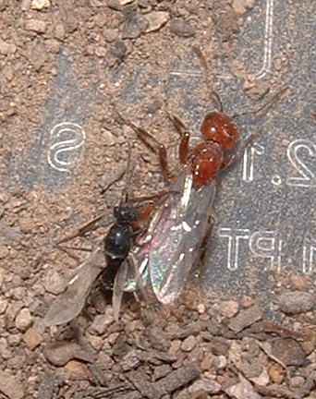



References:
Topoff, H. S. Cover, L. Greenberg, L. Goodloe, and P. Sherman. 1988. Colony founding by queens of the obligatory slave-making ant Polyergus breviceps: the role of the Dufour's gland. Ethology 78: 209-18.

Topoff, H. and L. Greenberg. 1988. Mating behavior of the socially-parasitic Ant Polyergus breviceps: the role of the mandibular glands. Psyche 95: 81-87.

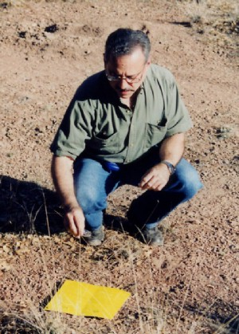
Polygerus queen (winged) with raiding workers.
Male Polyergus inseminates a female during a raid for “slave” brood.

Retirement/Farewell Party

On the night of July 19, 2003, Howard Topoff and Carol Simon hosted a retirement/farewell party for Wade, Emily, Skylar, and Reed Sherbrooke. A “grand old bar-b-que” served approximately 150 people: 60+ Station residents and 80+ people comprised of local residents and friends of the Station attended the event.
A good time was had by all!

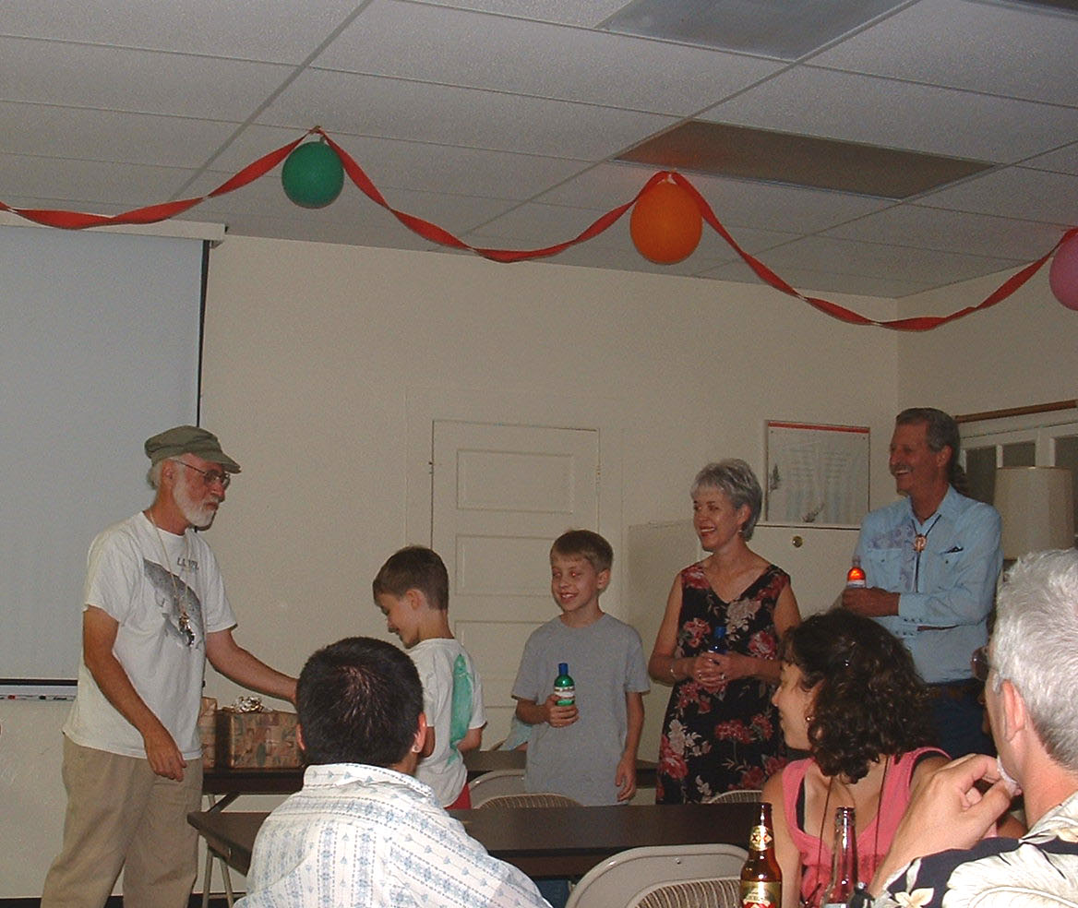

As thoughtful parting gifts, the Sherbrookes received antivenins specific to the most deadly creatures that they might anticipate encountering in Australia.

Les Greenberg with sticky trap used to capture male ants attracted to two volatile compounds identified from the mandibular glands of females.

Bittersweet Parting
From the Editor
The past 12 years of my life have been intertwined with the lives of the many people – researchers, volunteers, naturalists, and staff members – who have stayed at the Station for periods of time ranging from one or two days, to a year (or years) at a time. In the beginning, saying good-bye to people was a difficult task. Then, throughout the years, I began to realize that many of these people would be returning and I would look forward to seeing them “same time next year” and to my continuing relationships with them.
Alas, this year I will not be able to do so. As Wade, Skylar, Reed, and I depart from the Southwestern Research Station to embark upon a new adventure, I reflect upon my time here and wish to say a heartfelt good-bye to all of you who have become such an important part of my life. Please know that although I will not be here to greet you next year, I will be thinking of you and wishing you well.
Emily EW Sherbrooke
Assistant Director

Winter Reservations

SWRS is now accepting reservations for winter courses or groups. The dining room is closed in the winter, so you will have to provide your own food. Call for details:
520-558-2396, or e-mail: swrs@amnh.org

Naturalists may also make winter reservations – we have 2 rooms with kitchenettes available.

Reminder
A reminder to all scientists planning to conduct research at SWRS in 2004—please contact our office EARLY (January) to reserve space, request applications, etc. Make sure to get your applications back to us early, as well. We are already filling in rapidly and want to make sure we have space for YOU!
2003 SWRS Student Support Fund Donors

Continued thanks to all those who have donated to the SWRS Student Support Fund this past year. Your contributions are important – they help young scientists in the beginning years of their research. If you would like to contribute to the SWRS Student Support Fund this year, please return the insert in the center of this newsletter along with your contribution.
Our thanks this year go to:
John and Susan Alcock, Andy and Peggy Anderson,
Avis Anderson, Marion K. Armstrong, Joseph and Lou Bagnara, Leslie and Robert Baker, Dick and Linda Beidleman, Martha Bogert, Mr. and Mrs. William Bradley, Bayard and Martha Brattstrom, Kim Bredensteiner, Marlene and Charles Brown, Jack and Martha Carter, Theodore and Jean Cohn, Nancy and Steve Compton, Rock L. Comstock, Jr., Michael and Lynn Cropper, Maryann Danielson, Diane Davidson, James and Jean Davis, Carolyn and Robert Dearing, Donna Davidson Dee, Alan Ferg, Vanda and Peter France, Jordan and Miriam Francis, Stuart Fullerton, Fred and Nancy Gehlbach, Mark Gehlbach, Warner and Wendy Glenn, Michael D. Greenfield and Valery J. Terwillinger, Vernon and Ann Hall, Carol and Dexter Hake, Alan and Lucy Hinman, Barbara Hutchinson, Piotr Jablonski, R.T. Jackson, Madeleine L. James, Rudolf and Ursula Jander, Patricia R. Johns, Christina Keppel and Ray Bender, Rolf Koford and Bonnie Bowen, Alfred and Gloria Kulczycki, Melvin La Rue, Kurt and Jen and Luke Leuschner, Arthur Lewis, Stephen and Kathyanne Martin, Michelle Maton and Michael Schaeffer, Guy Miller, Pete and Barbara Miller, Steven Daniel Miller, Mary Ellen Morbeck and John Hoffman, Sarah T. Novak, John and Ruth Peacock, Shelley Phipps, Ron Quinn and Barbara Ellis-Quinn, Marcia Francis Rea, Joyce Gibson Roach, Donald and Mary Rose, Jerome and Barbara Rozen, Kathryn and Robert Scholes, Ruth Shilling, Peter Sundt, Richard Tinsley, Howard Topoff and Carol Simon, Claus and Clara Victorius, Chris and Judy Wallisch, Roberta and Maurice Ward, Peter and Mary Sue Waser, Betsey A. Weaver, Mary Willy, Sidney Wolf and Frankie Knibb, James and Andrea Wygle, Louis and Elizabeth Zimmer, Joseph Zipparo, and Richard and Frances Zweifel.

(through Nov. 2003)

Funding Opportunities
The American Museum of Natural History offers several grant programs to assist SWRS researchers.
• SWRS Student Support Fund – deadline February 15, 2004
• Theodore Roosevelt Memorial Fund – deadline February 15, 2004
• Chapman Fund – deadline January 15, 2004
For more information, and to obtain applications, contact: American Museum of Natural History, Office of Grants and Fellowships, Central Park West at 79th Street, New York, NY 10024; http://research.amnh.org/grants; phone: 212-769-5040.

SWRS Student Support Fund Recipients

This year the SWRS Student Support Fund supported the work of several researchers: Michael Castellano, St. Louis University, Effect of livestock removal on the herpetofauna of desertified arid grasslands; Josh Donlan, Cornell University, Woodrats and their community dynamics: species interactions along an elevational gradient; Paul Hamilton, Arizona State University, Life history of sexual selection in the phrysomatid lizards: a macroevolutionary approach; Elliot Wilkinson, University of Utah, Consequences of habitat physical characteristics to an important host ant trade-off.
Additionally, for the first time, the SWRS Student Support Fund awarded grants to two students participating in the advanced taxonomic courses that have been taking place at SWRS for the past several years: P. Allesh Sinu, Ashoka Trust for Research in Ecology and the Environment, Bangolore, India, for the Ant Course; and Carmen L. Yurita, Univeresidad de San Carlos, Guatemala City, Guatemala, for the Bee Course.

Notice

SWRS now accepts Visa, Mastercard, and Discover credit cards.

Positions Available
- VOLUNTEERS — Approximately 30 positions for graduate or undergraduate students and others interested in careers in biology and related fields. Food/lodging provided in exchange for 24 hrs/week routine chores; balance of time devoted to assisting scientists with research in the field or laboratory. March–October 2004.
For information, or to apply for the above positions, contact: Dawn S. Wilson, Director, Southwestern Research Station, American Museum of Natural
History, P.O. Box 16553, Portal, AZ 85632 USA; phone/fax: 520-558-2396; e-mail: swrs@amnh.org

2003 Volunteers

When you take a look at the origins of our volunteers, you begin to get a feel for the international flavor that we enjoy at the Southwestern Research Station – due, in large part, to people like the following who come to the Station and become part of our lives. We thank them all – not only for their many contributions while here – but also for the undefinable ways they enrich our lives while they are here.

Zornitza Aguilar (Ecuador), Katie Bairstow (England), Marek Borowiecz (Poland), Nick Cairns (Canada), Paul Catullo (Oregon), Lauren Chan (New York), Stevland Charles (Washington, DC), Jacqueline Clark (Arizona), Nicholas Dyer (England), Rachael Edwards (England), Dustin Fitzgerald (Indiana), Robin Greene (Montana), Steve Gross (Texas), Cedric Hall (Indiana), Ray and Ricky Harrington (Texas), Ronnie Hernandez (Trinidad), Bobby Holroyd (New Mexico), Brian Hockaday (Texas), Kelly Lasater (New Mexico), Dan Moen (North Dakota), Jonathan Moser (Utah), Yasmeen Qadim'asil (Washington, DC), Sean Powers (Oregon), Inga Richert (Germany), Susanne Schiller (Germany), Ewa Sergiej (Poland), Andréa Simon-Topoff (Arizona), Lance Sims (Washington, DC), Rowena Staff (England), Zoe Strong (England), Amanda Talaba (New York), and Nick Wallisch (Texas).

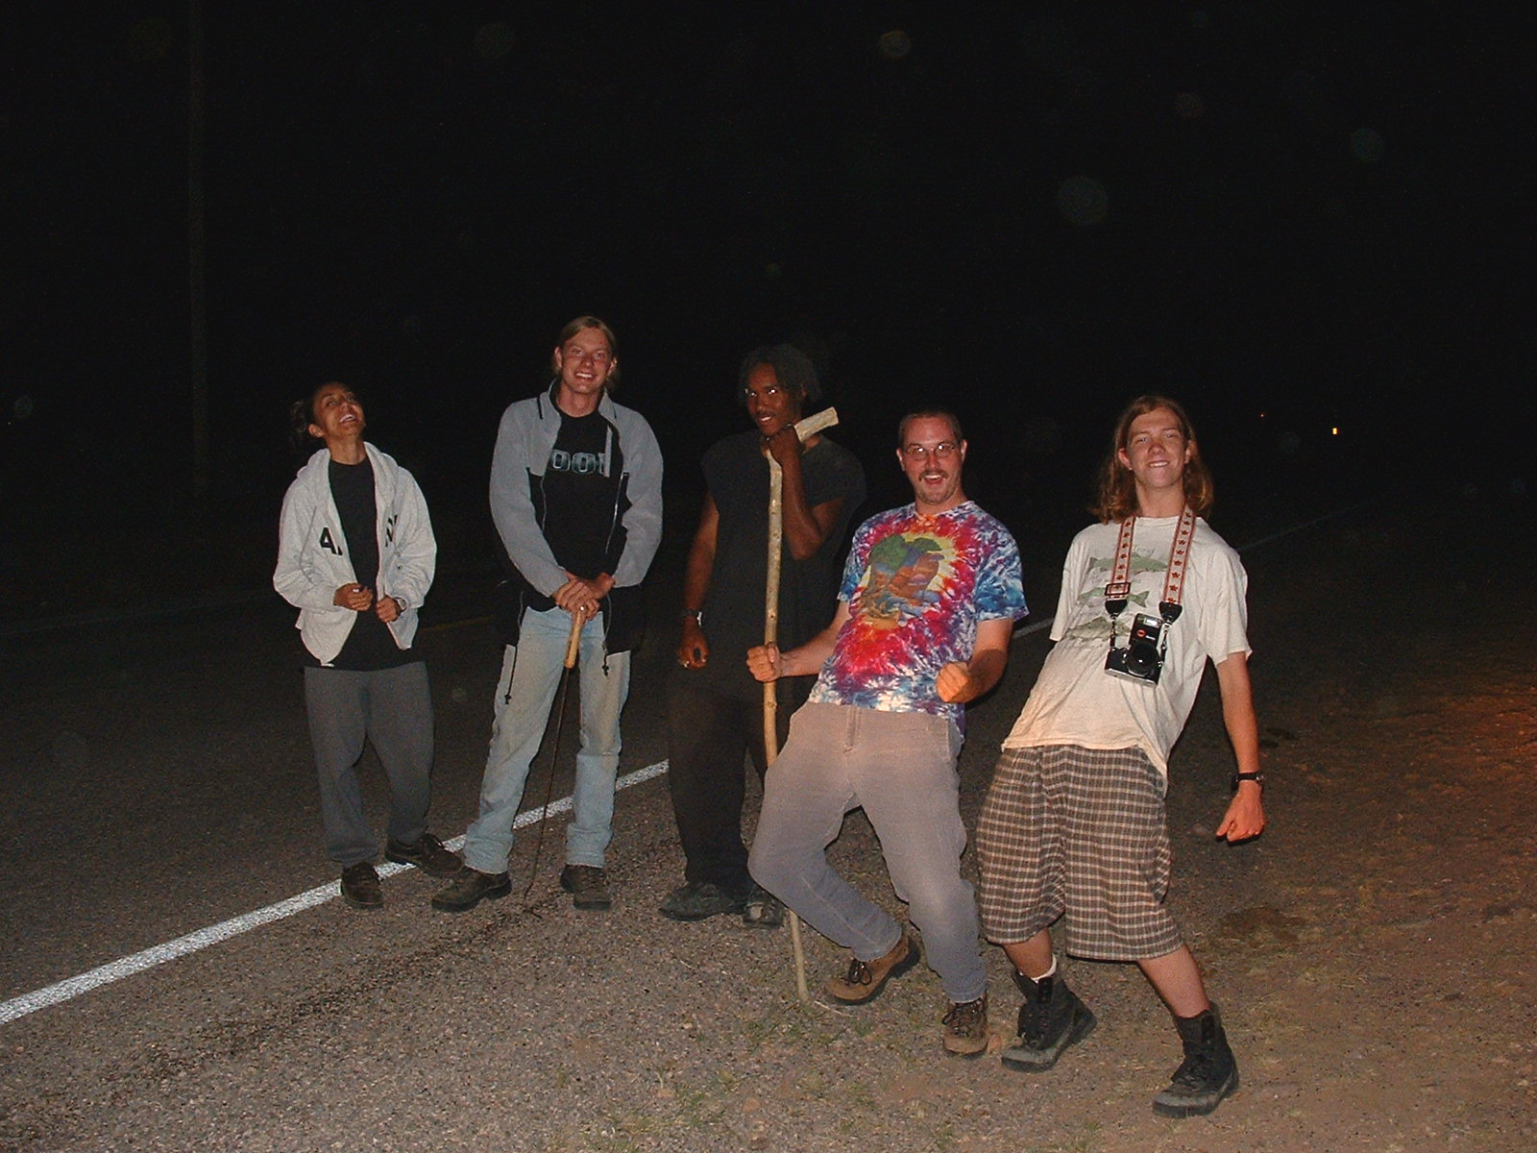

Volunteers Andréa Simon-Topoff, Marek Borowiecz, Cedric Hall, Nick Wallisch, and Nick Cairns “road cruising” for reptiles.
Field Research Assistant needed for study of the Mexican Jay in the Chiricahua Mts. April 1 to June 30, 2004. Duties include finding nests and observing breeding behavior of color-banded jays at and away from nests with binoculars and telescope. Applicants must be able to read and write color-band combinations without difficulty (not color-blind or dyslexic). Duties include nest-finding, nest-watching, trapping, banding and bleeding adults and nestlings. Applicants should have experience with some of these activities, be in good physical condition, and be willing to work long hours in hot and cold weather. Tree-climbing ability appreciated. Applicants should have experience studying birds and an interest in a future career in science. Must be able to work in a team and alone. Comfortable housing, meals, and a stipend of $100/wk will be provided at the Southwestern Research Station. Limited travel allowance available. Send a cover letter, resumé, and list of 3 references, including email addresses and phone numbers, to Jerram L. Brown, Dept. Biological Sciences, SUNY, Albany NY 12222. Questions to BJERRAM6@aol.com. Information about research on Mexican Jays can be accessed from Brown’s home page at
http://www.albany.edu/faculty/jlb81/



Publications

Andrews, F.G. 2001. A new species of Corticarina from Arizona (Latridiidae: Corticariini). Pan-Pacific Entomologist 77:37-38.
Bishop, N. 2000. Hunting the horned lizard. Pacific Learning, Huntington Beach, CA. 32 pp.
Bott, K., T. Brown, and D. Eifler. 2001. Phrynosoma cornutum (Texas Horned Lizard) diet. Herpetological Review 32:41.
Enderson, E.F., R.L. Bezy, W.C. Sherbrooke, and G.L. Bradley. 2001. Sceloporus jarrovii (Yarrow’s Spiny Lizard). USA: Arizona. Herpetological Review 32:57-58.
Frankino, W.A. 2000. The role of development in the origin and evolution of adaptive phenotypic plasticity. Ph.D. dissertation. Indiana University. 204 pp.
Frankino, W.A., and D.W. Pfennig. 2001. Condition-dependent expression of trophic polyphenism: effects of individual size and competitive ability. Evol. Ecol. Res. 3:939-951.
Gaimari, S.D., and M.E. Irwin. 2000. Phylogeny, classification, and biogeography of the cycloteline Therevinae (Insecta: Diptera: Therevidae). Zool. J. Linn. Soc. 129:129-240.
Gaimari, S.D., and M.E. Irwin, 2000. Revision of the Mexicana-group of the Cycloteline genus Ozodiceromyia Bigot (Diptera: Therevidae). Proc. Entomol. Soc. Wash. 102:561-600.
Greene, E. 1996. Effect of light quality and larval diet on morph induction in the polymorphic caterpillar Nemoria arizonaria (Lepidoptera:Geometridae). Biol. J. Linn. Soc. 58:277-285.
Greene, E. 1999. Phenotypic variation in larval development and evolution: polymorphism, polyphenism, and developmental reaction norms. Chapter 11, pp. 379-410, in The origin and evolution of larval forms, Academic Press.
Hopp, S.L., P. Jablonski, and J.L. Brown. 2001. Recognition of group membership by voice in Mexican jays, Aphelocoma ultramarina. Anim. Behav. 62:297-303.
Jablonski, P.G. 2001. Sensory exploitation of prey: manipulation of the initial direction of prey escapes by a conspicuous“rare enemy.” Proc. R. Soc. Lond. B 268:1017-1022.
Kay, A.D. 2000. The impact of nutrient balance on the acquisition and allocation strategies of ants. Ph.D. dissertation, University of Utah, Salt Lake City. 197 pp.
Manley, D.G., and W.C. Sherbrooke. 2001. Predation on velvet ants (Hymenoptera: Mutillidae) by Texas horned lizards (Phrynosoma cornutum). Southwest. Nat. 46:221-222.

Publications

Barton, A.M. 1992. Factors controlling lower elevational limits of plants: responses of pines to drought in the Chiricahua Mountains, Arizona. Pp. 191-194 in Symposium on ecology and management of oak and associated woodlands: perspectives in the southwestern US and northern Mexico. USDA Forest Service, Rocky Mountain Forest and Range Experimental Station, General Technocal Report RM-218.
Barton, A.M. 1994. Gradient analysis of relationships among fire, environment, and vegetation in a southwestern USA mountain range. Bull. Torrey Bot. Club 121:251-265.
Barton, A.M. 1995. Fire adaptations in pines and oaks: tree population responses to fire suppression in Arizona’s Madrean forests. Pp. 159-163 in J.K. Brown, R.W. Mutch, C.W. Spoon, and R.H. Wawkimoto, technical coordinators, Proceedings: symposium on fire in wilderness and park management: 1993 March 30-April 1; Missoula, MT. Tech. Rep. INT-GTR-320, US Forest Service, Intermountain Research Station, Ogden, UT.
Barton, A.M. 1999. Pines versus oaks: effects of fire on the composition of Madrean forests in Arizona. Forest Ecology and Management 120:143-156.
Barton, A.M. 2002. Intense wildfire in southeastern Arizona: transformation of a Madrean oak-pine forest to oak woodland. Forest Ecology and Management 165:205-212.
Barton, A.M., T.W. Swetnam, and C.H. Baisan. 2001. Arizona pine (Pinus arizonica) stand dynamics: local and regional factors in a fire-prone Madrean gallery forest of Southeast Arizona, USA. Landscape Ecology 16:351-369.
Brown, C.A. 2001. Allometry of offspring size and number in scorpions. Pp. 307-315 in V. Fet and P.A. Selden, eds., Scorpions 2001. In Memoriam Gary A. Polis. British Arachnological Society, Burhnam Beeches, United Kingdom.
Cahan, S.H., and L. Keller. 2003. Complex hybrid origin of genetic caste determination in harvester ants. Nature 424:306-309.
Christman, B.J. 2001. Factors influencing pair territoriality in the juniper titmouse. Condor 103:361-369.
Christman, B.J. 2001. Low flock coherence in mild winters leads to a lack of subordination costs in bridled titmouse foraging groups. Ibis 143:617-626.
Christman, B.J. 2002. Extreme between-year variation in productivity of a bridled titmouse (Baeolophus wollweberi) population. Auk 119:1149-1154.
Fatto, R.M. 2000. Several Russulas of the Chiricahua Mountains. Mycotaxon 75:265-272.
Duncan, W.W., F.R. Gehlbach, and G.A. Middendorf, III. 2003. Nocturnal activity by diurnal lizards (Sceloporus jarrovi, S. virgatus) eaten by small owls (Glaucidium gnoma, Otus trichopsis). Southwest. Nat. 48:218-222.
Fatto, R.M. 2002. Some Russulas of the subsection Urentinae. Mycotaxn 84:229-244.
Ficken, S.F., K.M. Rusch, S.J. Taylor, and D.R. Powers. 2002. Reproductive behavior and communication in blue-throated hummingbirds. Wilson Bull. 114:197-209.
Gehlbach, F.R. 2003. Body size variation and evolutionary ecology of eastern and western screech-owls. Southwest. Nat. 48:70-80.
Greene, M.J., and D.M. Gordon. 2003. Cuticular hydrocarbons inform task decisions. Nature 423:32.
Greenfield, M.D. 2002. Signalers and receivers: mechanisms and evolution or arthropod communication. Oxford University Press.
Greenfield, M.D., and W.A. Snedden. 2003. Selective attention and the spatio-temporal structure of orthopteran choruses. Behaviour 140:1-26.
Hews, D.K., and V.S. Quinn. 2003. Endocrinology of species differences in sexually dichromatic signals: using the organization and activation model in a phylogenetic framework. Pp. 253-277 in S.F. Fox, J.K. McCoy, and T.A. Baird, eds. Lizard social behavior. John Hopkins University Press, Baltimore, MD.
Jablonski, P. 2003. Foraging behvior and insect brains. Interpretive Birding 4:27-29.
Johnson, C.A., R.K. Vander Meer, and B. Lavine. 2001. Changes in the cuticular hydrocarbon profile of the slave-maker ant queen, Polyergus breviceps Emery, after killing a Formica host queen (Hymenoptera:Formicidae). J. Chem. Ecol. 27:1787-1804.
LeBrun, E.G., and D.H. Feener, Jr. 2002. Linked indirect effects in ant-phorid interactions: impacts on ant assemblage structure. Oecologia 133:599-607.
Lytle, D.A. 2000. Biotic and abiotic effects of flash flooding in a montane desert stream. Arch. Hydrobiol. 150:85-100.
Lytle, D.A. 2001. Disturbance regimes and life-history evolution. Am. Nat. 157:525-536.
Lytle, D.A. 2002. Flash floods and aquatic insect life-history evolution: evaluation of multiple models. Ecology 83:370-385.
Lytle, D.A. 2003. Reconstructing long-term flood regimes with rainfall data: effects of flood timing on caddisfly poulations. Southwest. Nat. 48:36-42.
Middendorf, G.A., III, and B. Grant. 2003. The challenge of environmental justice. Frontiers in Ecology and the Environment 1:154-55.
Nelson, J.G., J.C. Day, L.M. Spotza, J. Loucky, and C. Vasquez, eds. 2003. Protected areas and the regional planning imperative in North America. University of Calgary Press and Michigan State University Press. 429 pp.
Ohl, M., and D. Linde. 2003. Ovaries, ovarioles, and oocytes in apoid wasps, with special reference to cleptoparasitic species (Hymenoptera: Apoidea: “Sphecidae”). J. Kansas Entomol. Soc. 76:147-159.
Oliver, D.K. 2003. Tracks in the sand: tales from outside city limits. Bandit Press, Duncan, Arizona (privately published).
Pfennig, D.W., W.R. Harcombe, and K.S. Pfennig. 2001. Frequency-dependent Batesian mimicry. Nature 410:323.
Pfennig, D.W., and P.J. Murphy. 2000. Character displacement in polyphenic tadpoles. Evolution 54:1738-1749.
Pfennig, D.W., and P.J. Murphy. 2002. How fluctuating competition and phenotypic plasticity mediate species divergence. Evolution 56:1217-1228.
Pfennig, K.S., and M.A. Simovich. 2002. Differential selection to avoid hybridization in two toad species. Evolution 56:1840-1848.
Pfennig, K.S., and R.C. Tinsley. 2002. Different mate preferences by parasitized and unparasitized females potentially reduces sexual selection. J. Evol. Biol. 15:399-406.
Pytte, C.L., K.M. Rusch, and M.S. Ficken. 2003. Regulation of vocal amplitude by the blue-throated hummingbird, Lampornis clemenciae. Animal Behaviour 66:703-710.
Rüppell, O., J. Heinze, and B. Hölldobler. 2001. Alternative reproductive tactics in the queen-size-dimorphic ant Leptothorax rugatulus (Emery) and their consequences for genetic population structure. Behav. Ecol. Sociobiol. 50:189-197.
Rüppell, O., J. Heinze, and B. Hölldobler. 2001. Complex determination of queen body size in the queen size dimorphic ant Leptothorax rugatulus (Formicidae: Hymenoptera). Heredity 87:33-40.
Rüppell, O., J. Heinze, and B. Hölldobler. 2001. Genetic and social structure of the queen size dimorphic ant Leptothorax cf. andrei. Ecol. Entomol. 26:76-82.
Rüppell, O., J. Heinze, and B. Hölldobler. 2002. Intracolonial patterns of reproduction in the queen-size dimorphic ant Leptothorax rugatulus. Behav. Ecol. 13:239-247.
Rüppell, O., J. Heinze, and B. Hölldobler. 2002. Sex ratio variation in a facultatively polygynous ant with size-dimorphic queens. Ethol. Ecol. Evol. 14:53-67.
Rüppell, O., L. Schäffler, and B. Hölldobler. 2002. Lack of plasticity in the behavior of queens of the ant Leptothorax rugatulus Emery (Formicidae: Hymenoptera). J. Insect Behav. 15:447-454.
Rüppell, O., M. Strätz, B. Baier, and J. Heinze. 2003. Mitochondrial markers in the ant Leptothorax rugatulus reveal the pouplation genetic consequences of female philopatry at different hierarchical levels. Molecular Ecology 12:795-801.
Salazar, B.A., and D.W. Whitman. 2001. Defensive tactics of caterpillars against predators and parasitoids. Pp. 161-207 in T.N. Ananthakrishnan, ed., Insects and plant defense dynamics. Science Publishers, Inc. Plymouth, UK.
Sherbrooke, W.C. 2003. Introduction to horned lizards of North America. University of California Press, Berkeley. 178 pp.
Sloane, S.A. 2001. Bushtit (Psaltriparus minimus). In A. Poole and F. Gill, eds., The Birds of North America, No. 598. The Birds of North America, Inc., Philadelphia, PA.
Stauffer, T.W., and D.W. Whitman. 1997. Grasshopper oviposition. Pp. 231-280 in S.K. Gangwere, M.C. Muralirangan, and M. Muralirangan, eds., The bionomics of grasshoppers, katydids and their kin. CAB International, London, UK.
Topoff, H. 2003. Slave-driving ants on a mission to survive. Arizona Highways 79:42-43.
Weiss, S.L. 2002. Effect of captivity in semi-natural enclosures on the reproductive endocrinology of female lizards. Gen. Comp. Endocrinol. 128:238-246.
Weiss, S.L. 2002. Reproductive signals of female lizards: pattern of trait expression and male response. Ethology 108:793-813.
Whitman, D.W., M.S. Blum, and F. Slansky, Jr. 1994. Carnivory in phytophagous insects. Pp. 161-205 in T.N. Ananthakrishnan, ed., Functional dynamics of phytophagous insects. Oxford & IBH Publishing Co., New Delhi, India.

Nonprofit Org.
U.S. Postage Paid
San Simon, AZ 85632
Permit No. 436105
American Museum of Natural History
Southwestern Research Station
P.O. Box 16553, Portal, AZ 85632
Phone/FAX: 520-558-2396; e-mail: swrs@amnh.org http://research.amnh.org/swrs/
Please affix postage, forward, and notify sender of change of address.
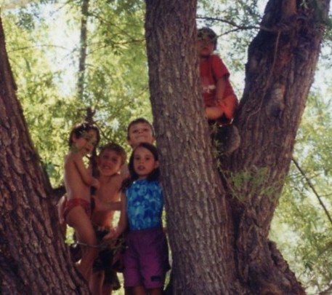
Out on a limb – Skylar and Reed Sherbrooke, Taran and Daniel Roth, and Emily Middendorf scope out sites for a future research endeavor.

